# PROJECT REPORT

# CRM APPLICATION FOR SCHOOL & COLLEGE

# 1. I NTRODUCTION

# 1.**1 Overview:**

**"This program enables a student to know about the educational facilities and college features as per his choice".**

## 1.2 Purpose:

## 1."You can know the complete information of a educational institution".

**2."You can find information about the fee details of a educational institution".**

**3."One can know the complete guidelines for the training capacity of an educational institution".**

# 2. Problem Definition & Design Thinking

**2.1 Empathy Map**

# 

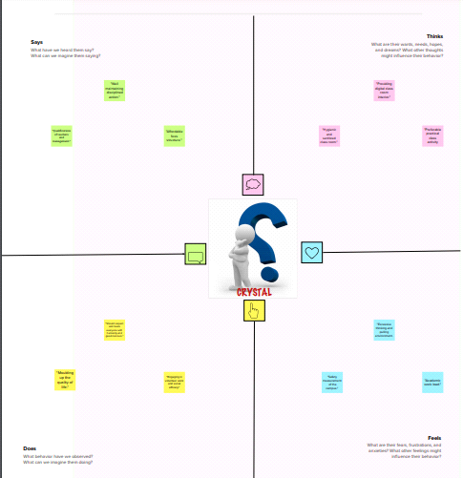

2.2 Ideation& Brainstorming Map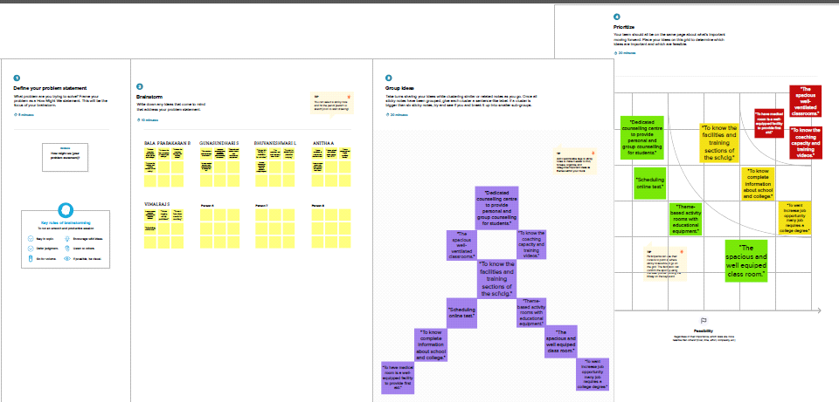

**3. Result**

**3.1 Data Model:**

|  |  |
| --- | --- |
| **Object name** | **Fields in the Object** |
| **School** | |  |  | | --- | --- | | **Field label** | **Data type** | | **Address** | **Text Area(255)** | | **District** | **Text Area(255)** | | **Highest Marks** | **Roll-up summary** | | **No.of.students** | **Roll-up summary** | | **Phone number** | **Phone** | | **School** | **Text Area** | | **State** | **Text Area** | | **School name** | **Text** | |
| **Student** | |  |  | | --- | --- | | **Field label** | **Data type** | | **Class** | **Number** | | **Enter result** | **Look up** | | **Marks** | **Number** | | **Parent address** | **Text Area** | | **Parent number** | **Phone** | | **Phone number** | **Phone** | | **School** | **Master-Detail** | | **Student name** | **Text** | |
| **Parent** | |  |  | | --- | --- | | **Field Label** | **Data type** | | **Parent name** | **Text** | |

**3.2 Activity & Screenshot**

**Milestone 1: Salesforce**

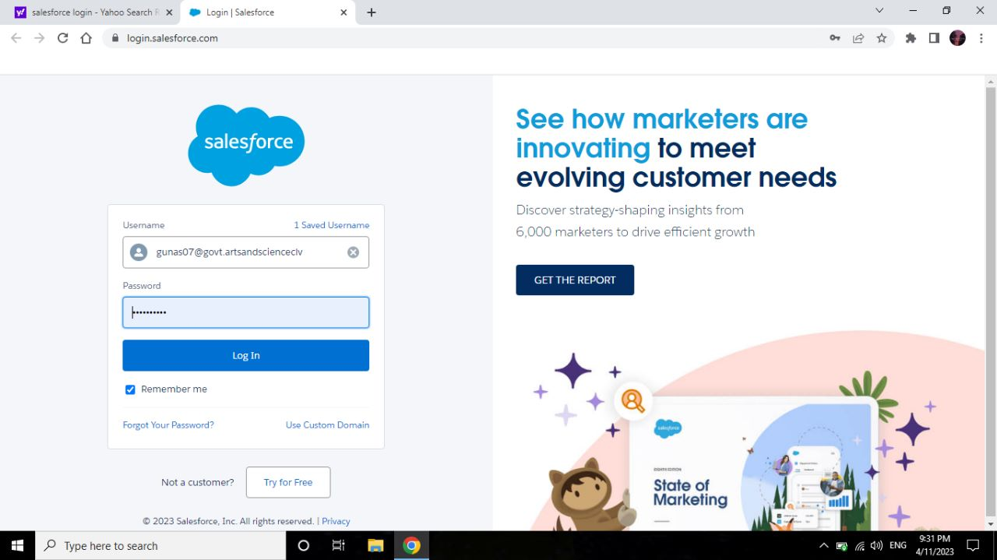

**Milestone 2: Object**

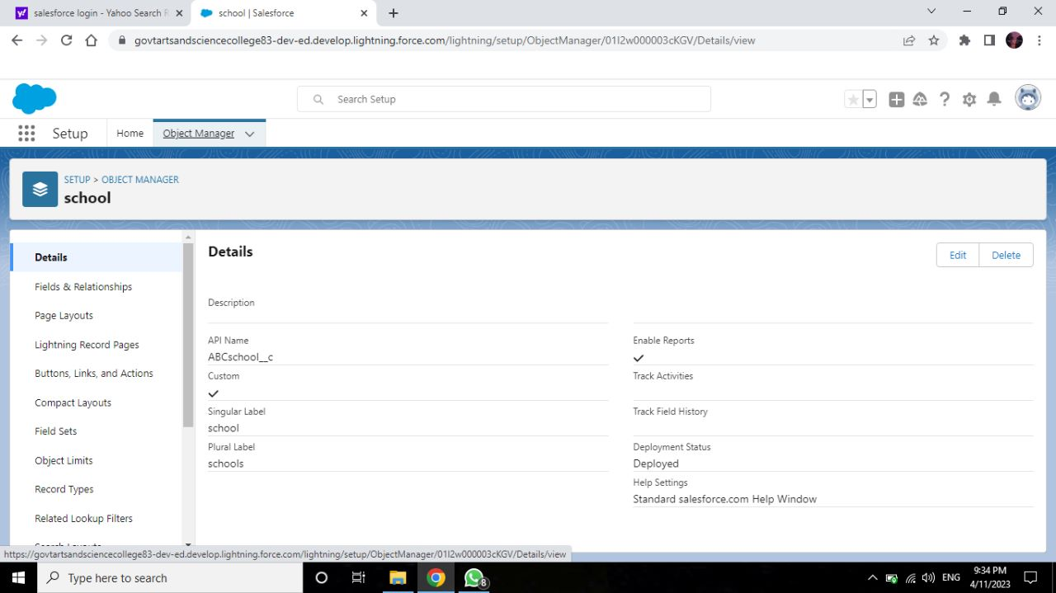

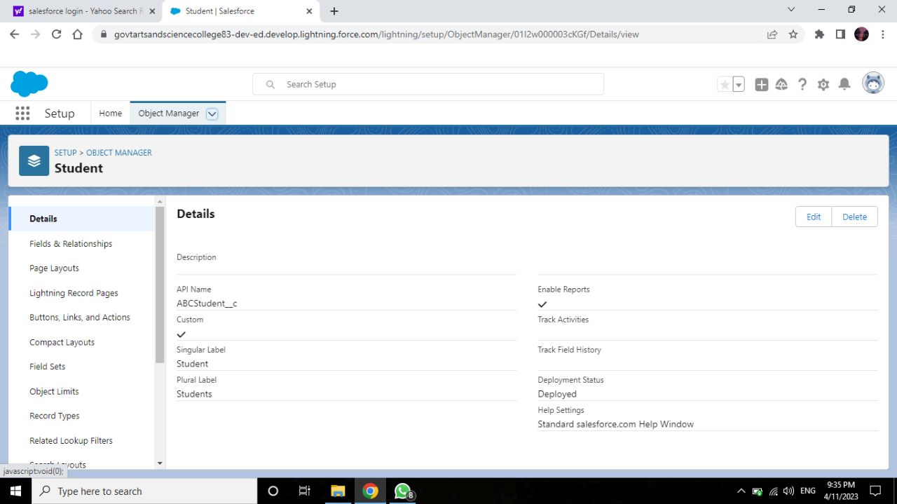

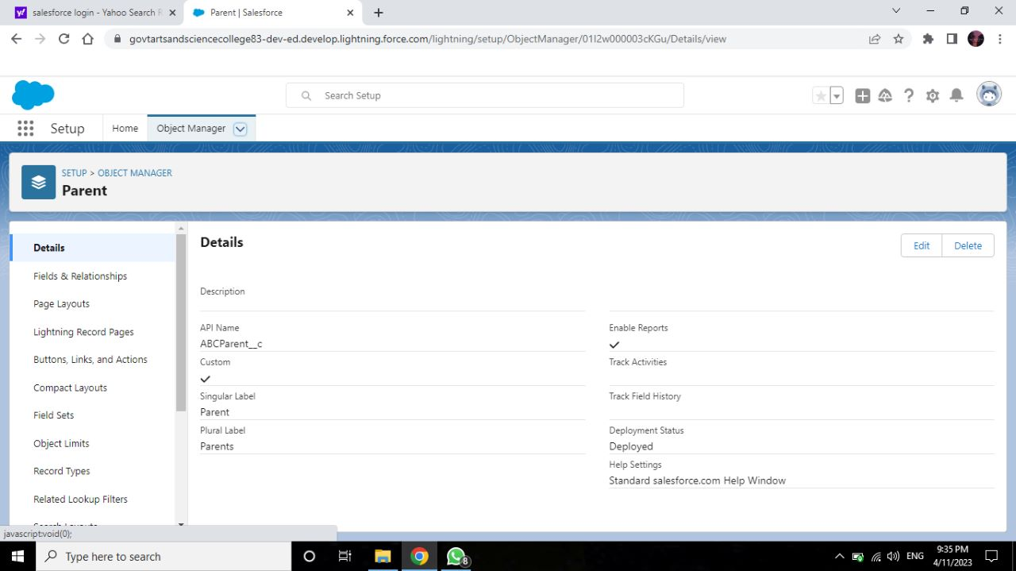

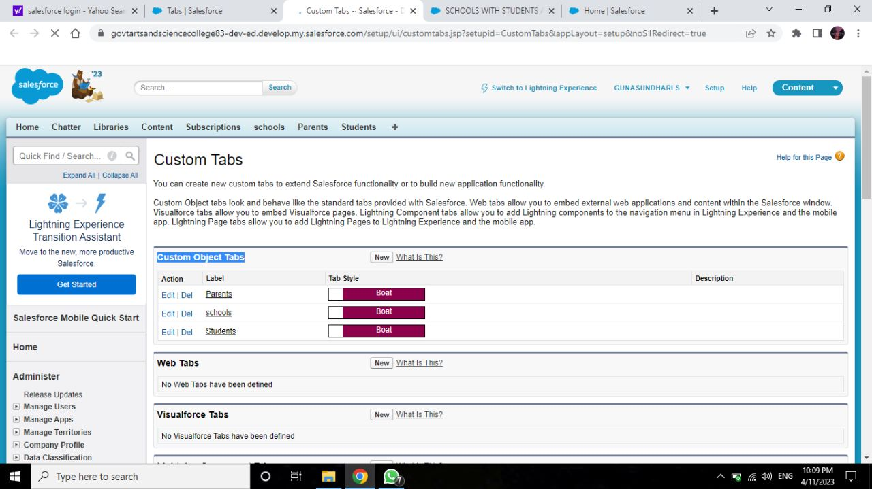

**Milestone-3:Lightning App**

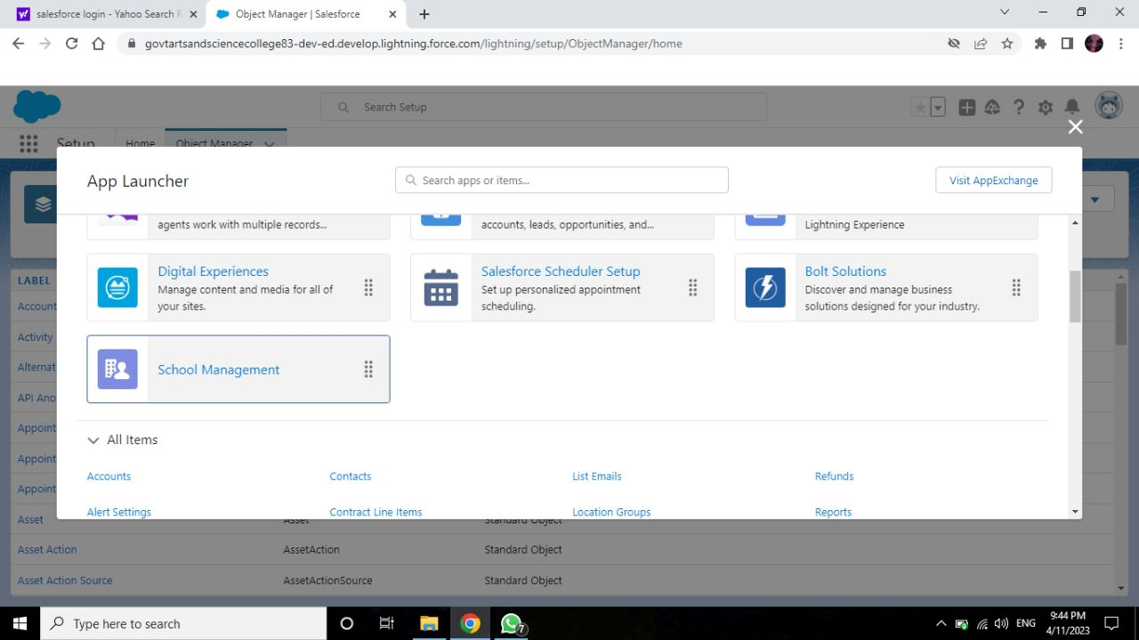

**Milestone-4:Fields & Relationship** 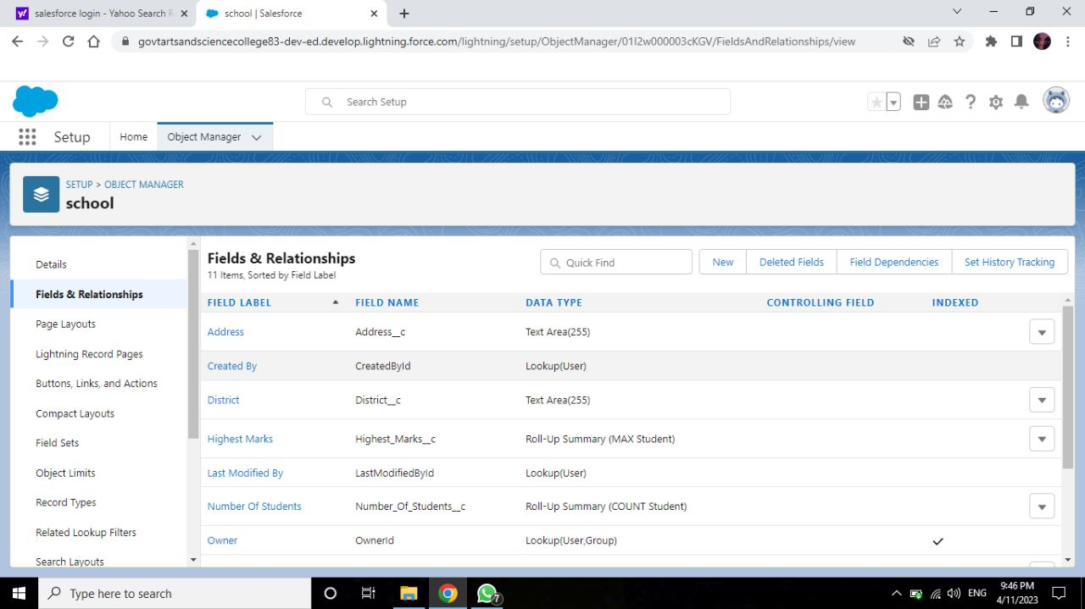

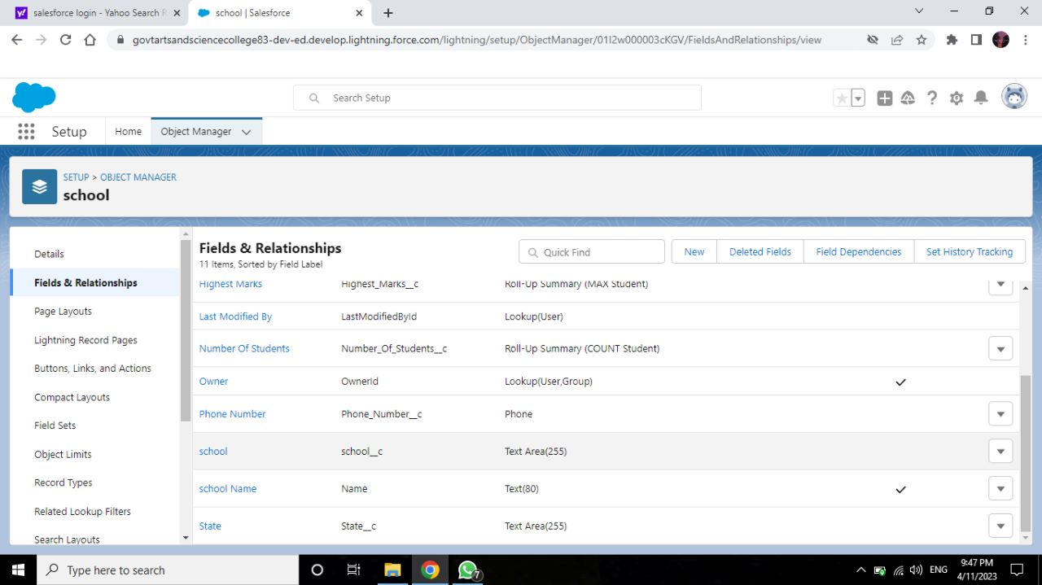 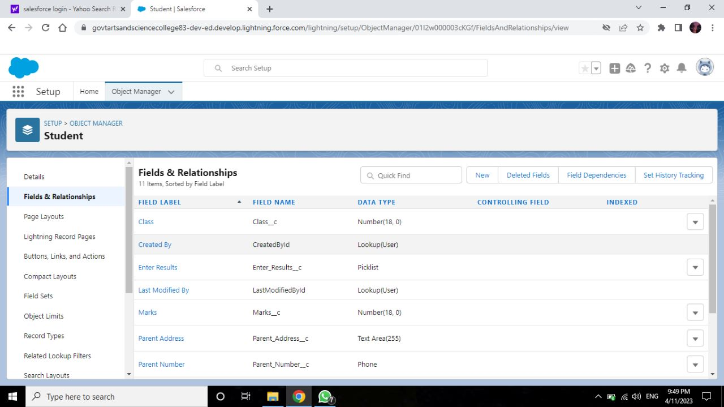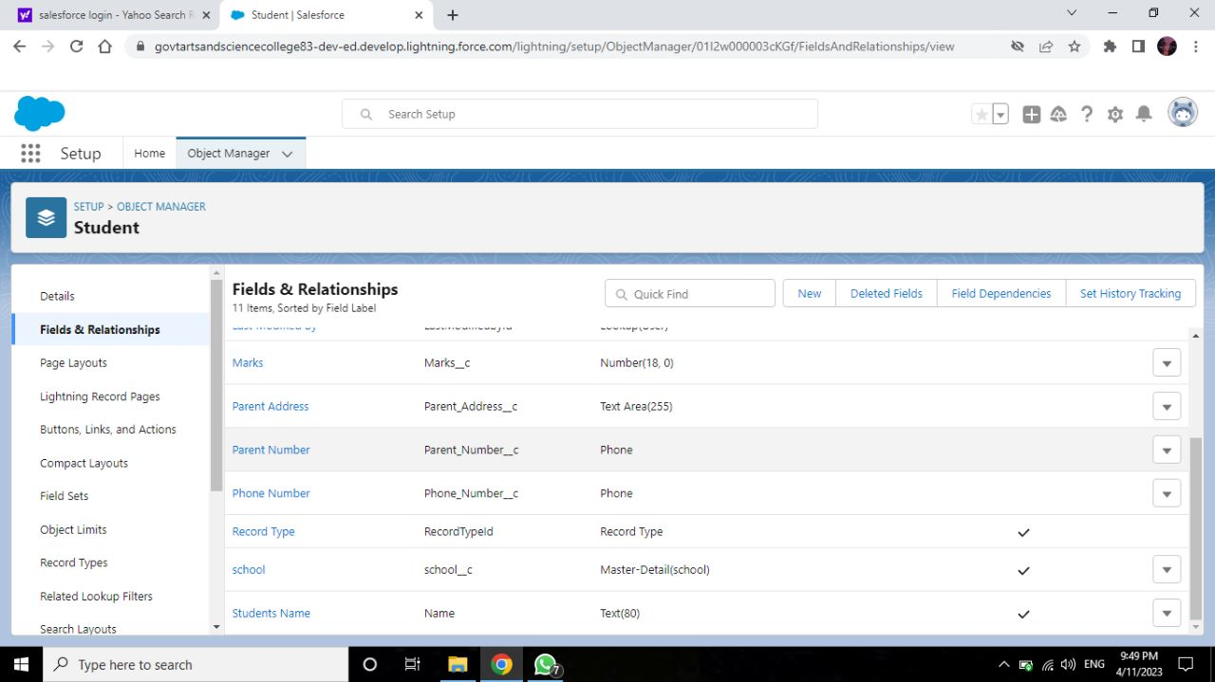 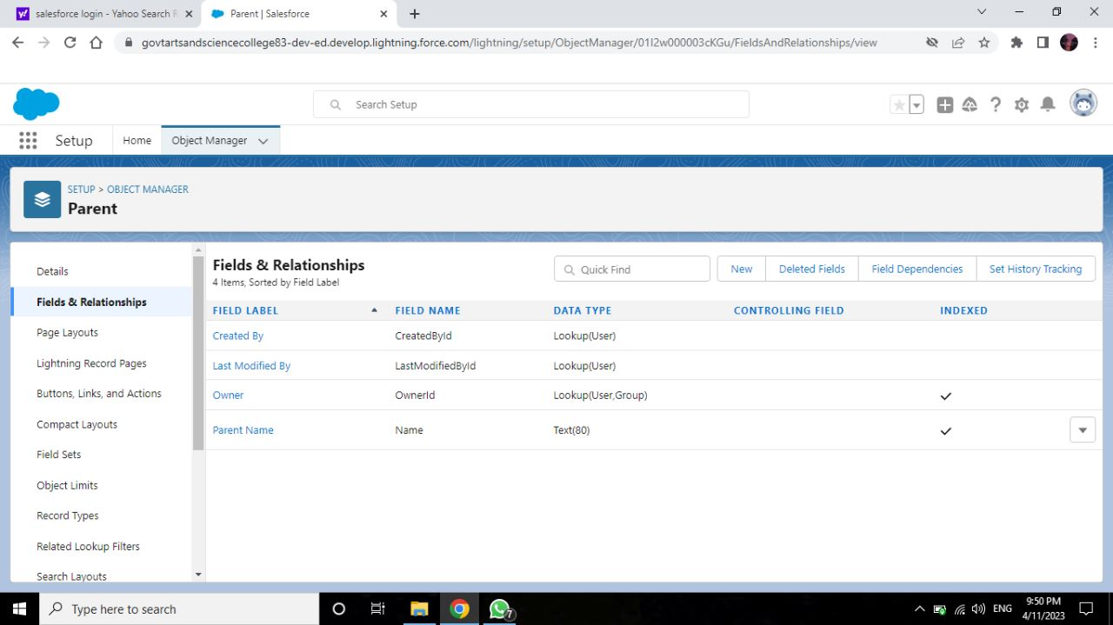

**Milestone-5:Profile**

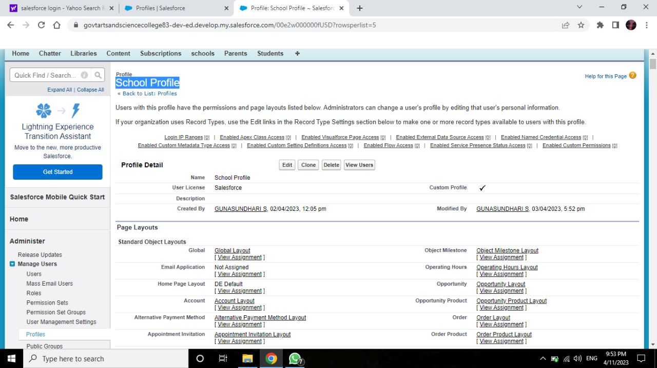

**Milestone-6:Users**

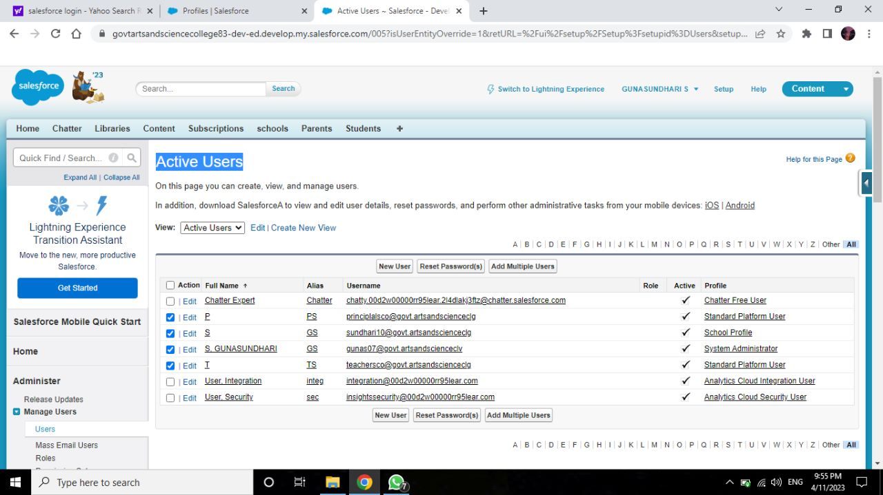

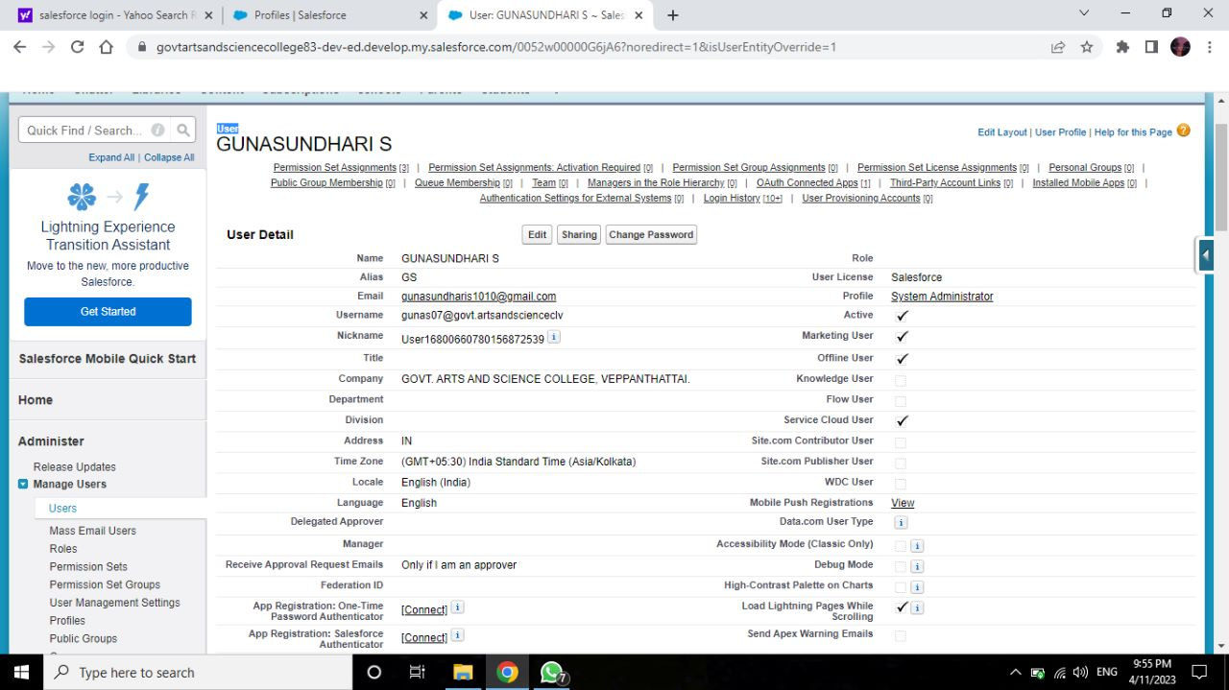

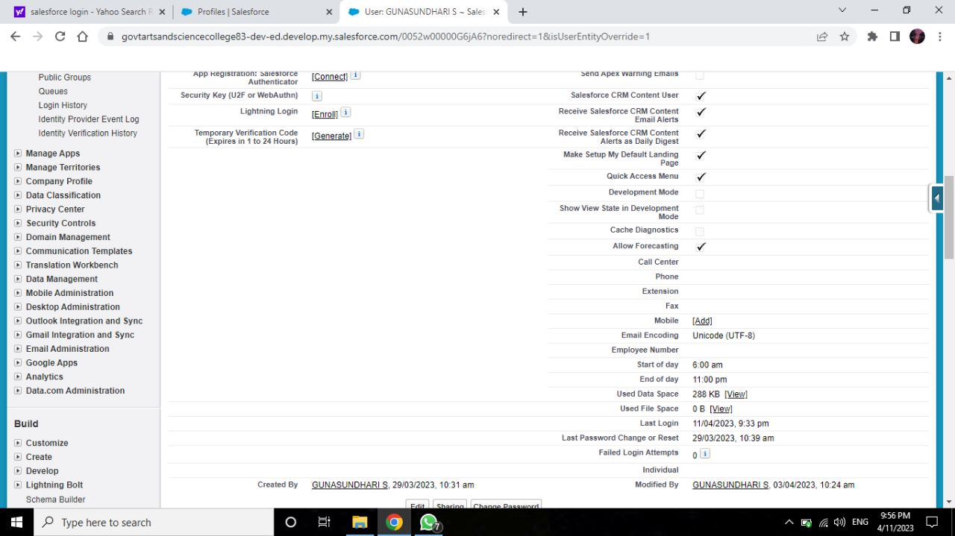

**Milestone-7:Permission Sets**

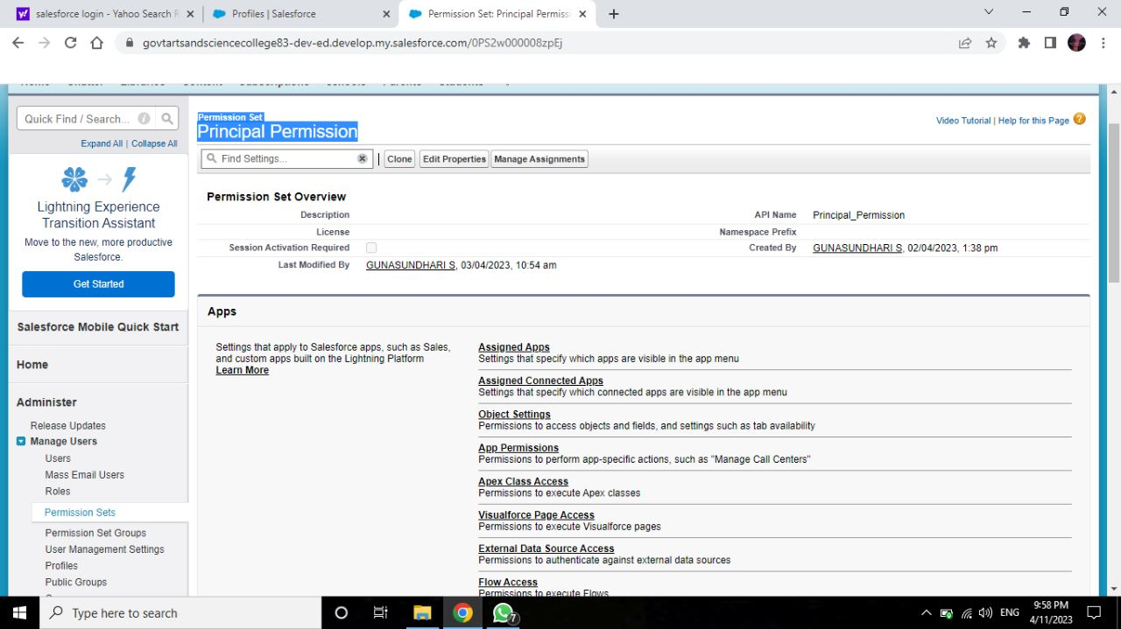

**Milestone-8:Reports**

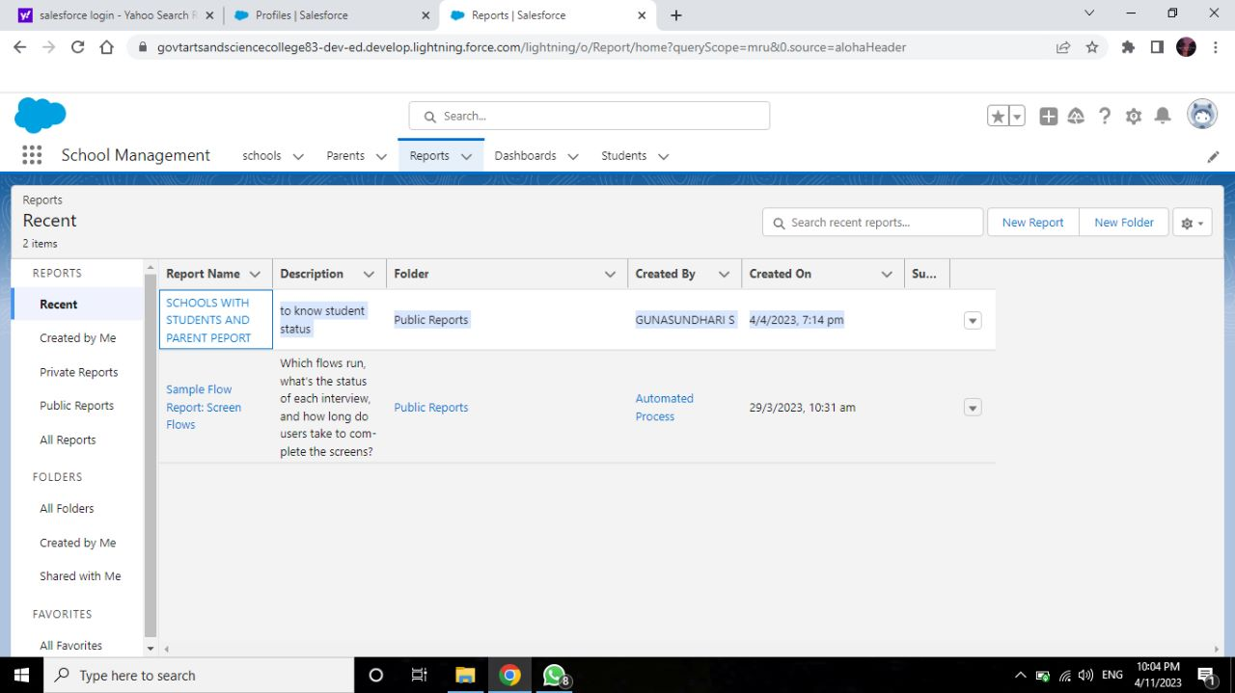

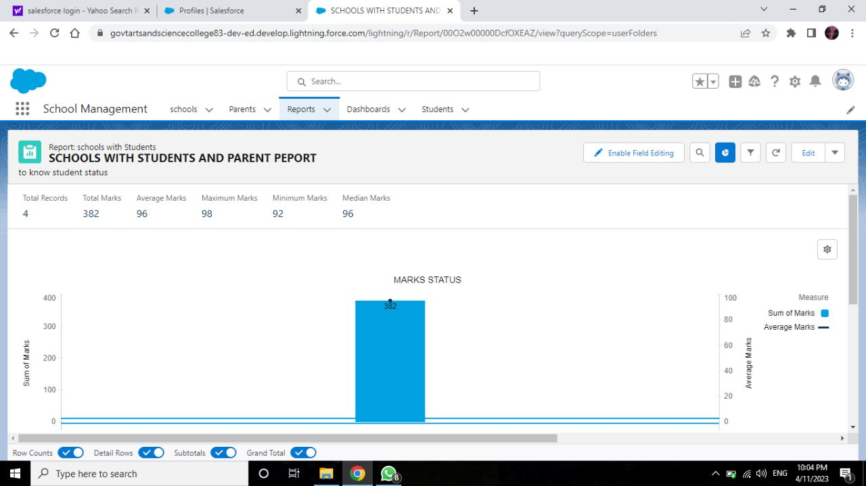

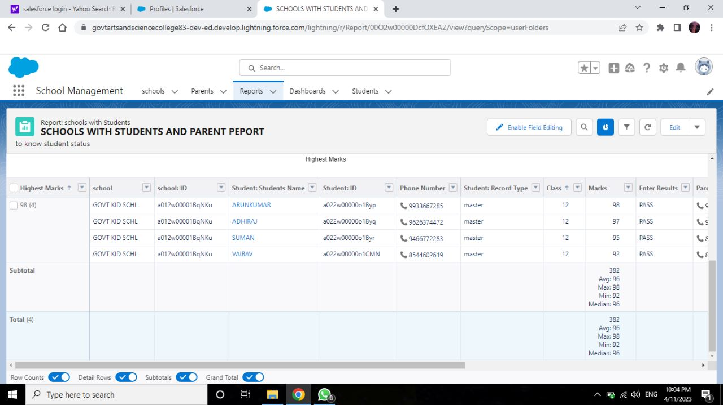

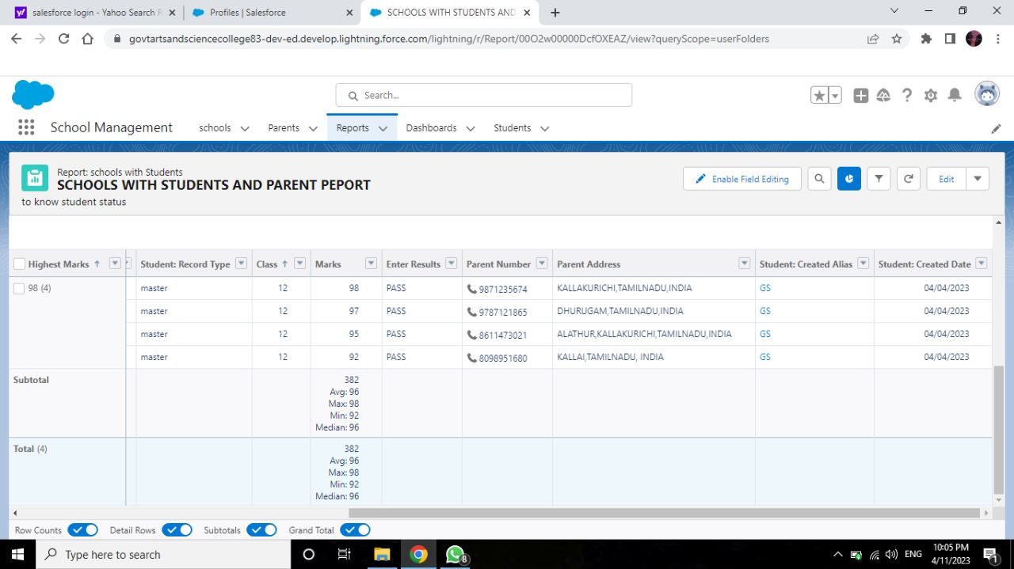

**4. Trailhead Profile Public URL**

**Team Lead -** [**https://trailblazer.me/id/balab65**](https://trailblazer.me/id/balab65)

**Team Member 1 -** [**https://trailblazer.me/id/gunas07**](https://trailblazer.me/id/gunas07)

**Team Member 2 -** [**https://trailblazer.me/id/bhuvI1**](https://trailblazer.me/id/bhuvI1)

**Team Member 3 -** [**https://trailblazer.me/id/aanitha35**](https://trailblazer.me/id/aanitha35)

**Team Member 4 –** [**https://trailblazer.me/id/vtamil10**](https://trailblazer.me/id/vtamil10)

**5. ADVANTAGES & DISADVANTAGE**

|  |  |
| --- | --- |
| **ADVANTAGE** | **DISADVANTAGE** |
| “Customer accounting and complete information about the relationship with them; | “ Security issues”. |
| “Schedule of classes and information on the educational process, by student; | “Third Party Access”. |
| “Personal accounts of students and teachers with the ability to upload homework and receive feedback; | “The excess initial time and productivity cost of implementation”. |

**6. APPLICATION**

* Get more enrollments a cost that makes sense
* Grow your student numbers predictably and reliably
* Less management no headaches
* Fees structures

**7. CONCLUSION**

* + **At lost, I would like to share my experience while doing this project**
  + **This project is school and college management is designed mainly for the purpose of managing all activities like admission, student performance etc …**

**8. FUTURE SCOPE**

* + **The future of CRM is about which companies will be able to pivot to meet the changing needs trends-driven by customer expectations.**
  + **Customers expect organizations to know a lot about them and expect to have conversations.**